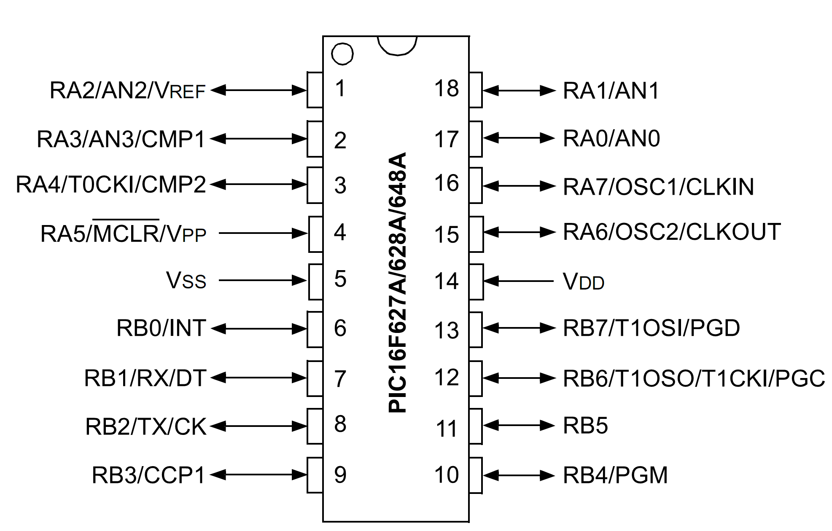

 | RA2 | 1 | PIC16F628A | 18 | RA1
 | RA3 | 2 | PIC16F628A | 17 | RA0
 | RA4/TOCK1 | 3 | PIC16F628A | 16 | RA7
 | RA5/MCLR | 4 | PIC16F628A | 15 | RA6
 | VSS | 5 | PIC16F628A | 14 | VDD
 | RB0 | 6 | PIC16F628A | 13 | RB7
 | RB1 | 7 | PIC16F628A | 12 | RB6
 | RB2 | 8 | PIC16F628A | 11 | RB5
 | RB3 | 9 | PIC16F628A | 10 | RB4

